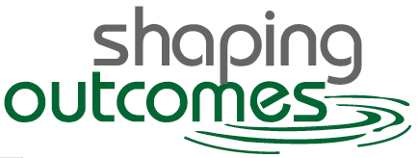 Logic Model Worksheet

Name: |  | Date:
I. Situation: program partners and stakeholders
What is the program’s name?
What partners are involved?

Who are the program’s stakeholders? | What does each stakeholder want to know? (Be sure to include yourself, your target audience, partners and any other stakeholders.)
II. Program planning: connecting needs, solutions, and results
Who are the audiences?
What are the needs of the audience?
What are some audience considerations?
What solution fulfills the needs?
What will be the desired results?

III. Logic model summary: program purpose statement
We do what?
For whom?
For what outcome/benefit(s)?
IV. Program elements
Inputs |  | Outputs (or counts)
Activities |  | Outputs (or counts)
Services |  | Outputs (or counts)

V. Outcomes
Outcome 1:
Indicator(s) | Applied to | Data Source | Data Interval | Target
Outcome 2:
Indicator(s) | Applied to | Data Source | Data Interval | Target
Outcome 3:
Indicator(s) | Applied to | Data Source | Data Interval | Target
Outcome 4:
Indicator(s) | Applied to | Data Source | Data Interval | Target

